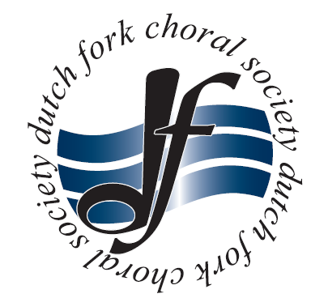
Dutch Fork Choral Society Program Advertising Rates – 2018-2019
Advertise your special events or big sales with an eye-catching ad in our program that stands out. Your ad will be printed in programs for all regular performances for the current season!

Choose an ad size in our 8.5x11” program
Full Page – $200.00 (You can use this to make a statement. Advise the reader to leave it on the counter or post it on their bulletin boards.)
Half Page – $100.00 (Use as a great promotional take-away to keep customers coming.)
Quarter Page -- $50.00
Eighth Page -- $25.00

DEADLINES
Advertising deadlines are 23 business days before the concerts mentioned below.

PAYMENT POLICY
All payments are due with advertising.
Make the check payable to Dutch Fork Choral Society and mail it to PO Box 223, Chapin, SC 29036.

DFCS performs three concerts per season, the first is Nov. 30, 2018 @ St. Mary’s Episcopal Church 7:30, 2nd is Feb 22, 2018 @ Our Lady of the Lakes and 3rd is May 2, 2019 @ Chapin United Methodist Church. We will be confirming the specific times as time draws nearer to the concerts in Feb. and May.

Give a DFCS representative details and print-ready artwork.

Thank you for partnering with us!

Signature contact __________________________Printed Name________________________

Company name __________________________________________________
Company contact name ___________________________________________
Address _____________________________________________________________
Phone _________-_________; Email _____________________________

FOR OFFICE USE ONLY
Ad size: full__1/2__1/4___1/8___ Paid Amount______
Contact Name________________________ Company name __________________________________________
Address _____________________________________________________________
Phone _________-_________; Email _____________________________

